Search Skills - Lab Report

Date: 19/05/2026
Difficulty: Easy
Category: Search Tools
Platform: TryHackMe

Overview

This lab focuses on learning and exploring tools and services which can help gather information for cyber security in either defensive or offensive situations. They can be used to find exploits, explore vulnerabilities or learn how a tool works. This lab gives a description of each tool or service and also gives an example of what was completed in the lab.

2. Toolset Used

Tool | Purpose / Function
Shodan | Scans the internet for IoT, network equipment and anything with a public network connection.
VirusTotal | Collects the results from 70+ antivirus and website scanners into a single application. Use it by uploading a file, URL, Domain or file hash to see if it is malicious or not.
Vulnerability Database (CVE) | A universal dictionary of known vulnerabilities which assigns each confirmed vulnerability with a unique identifier
Technical Documentation (MAN) | Linux MANual pages provide documentation that can be read within the terminal about any command or tools on Linux (man <command>)
GitHub | GitHub can be used to stay updated with the latest threats and vulnerabilities as researchers publish reports, tools and proof-of-concept (PoC) code there. Although be wary as not all can be trusted.

3. What I did

Shodan – I searched the term “apache” which is for the popular web server. This then returned information such as IP address, location, ISP and Domains.

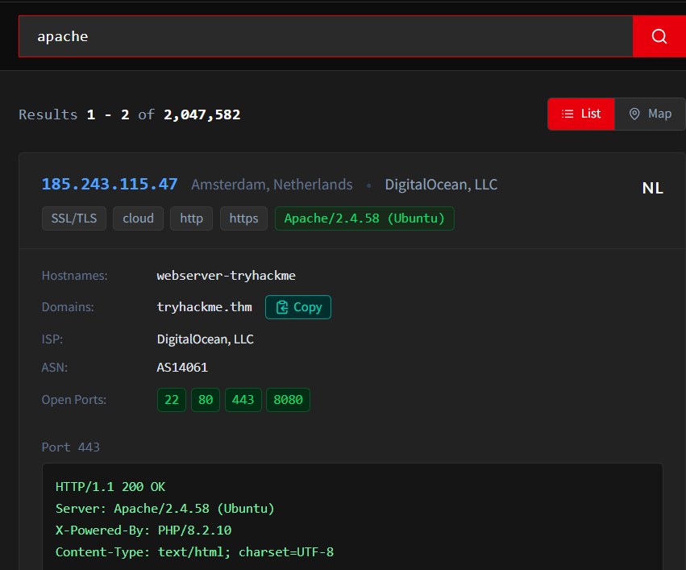

VirusTotal – I searched for the file “invoice_payment.exe” which returned the results for the malicious file. It had a community score of -15 and 52 vendors detected this file.

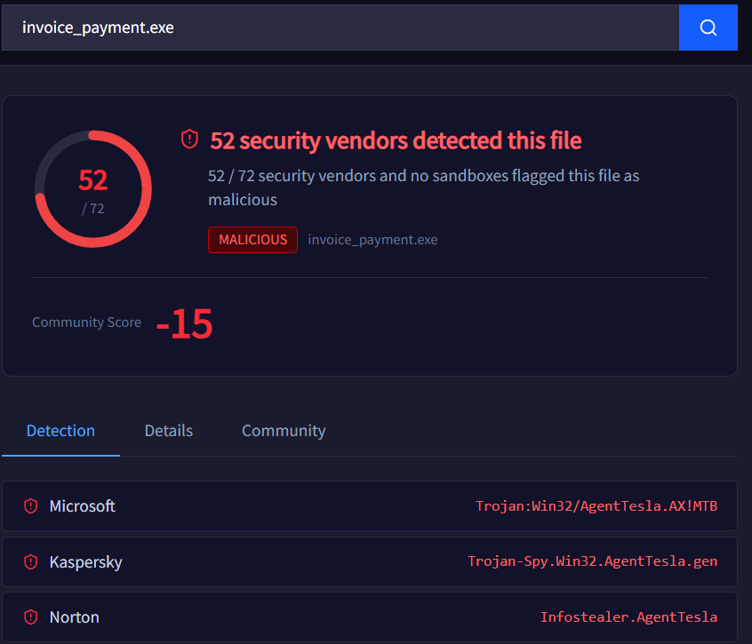

CVE – I searched for the vulnerability “CVE-2026-1337” which returned when the vulnerability was published, a description of it and the CVSS score which determines how critical it is. This vulnerability scored the highest possible score with 10 and the description tells us that it is an SQL injection attack.

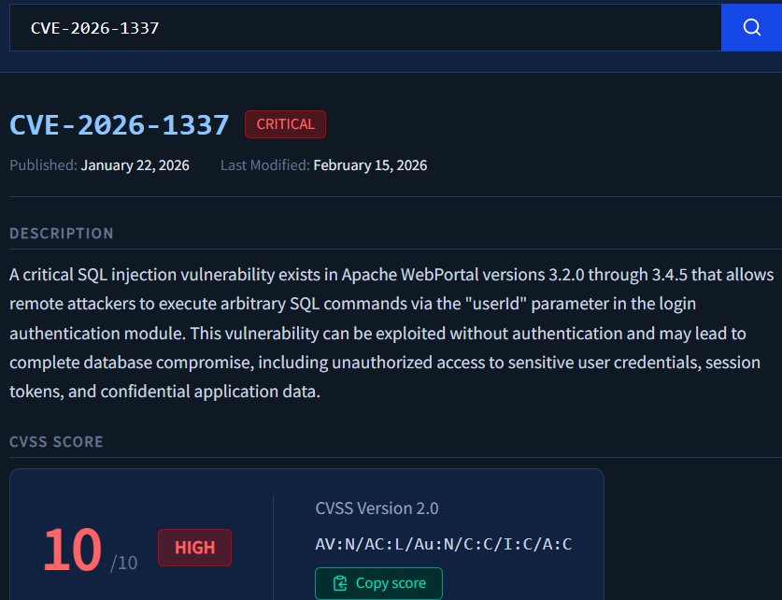

MAN – The example was using the tool nc (netcat) so I was tasked with searching the MANual pages for the tool nc and find the example command that allows you to open a connection. To do this is I wrote man nc in the Linux terminal and scrolled to the bottom which showed the example command as seen below.

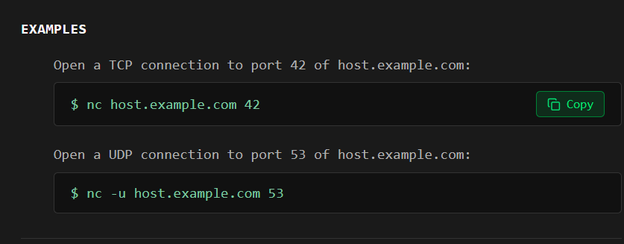

GitHub – I searched for the CVE “CVE-2026-1337” which returned a PoC code “exploit.py” and a “README” document which gave a description of the vulnerability and how to use it.

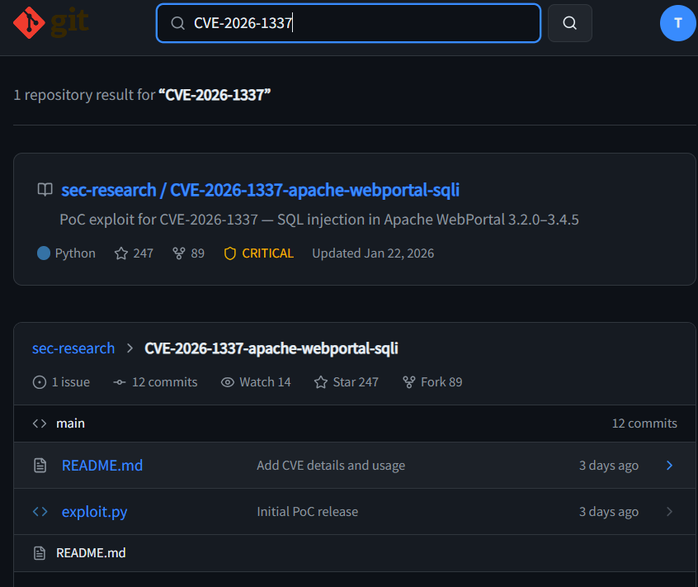

4. What I’ve learned

In this lab, I learned that there are various tools and services which can be used to gather information about tools, exploits and vulnerabilities. These will be useful for both offensive and defensive cyber security as they give different information depending on what you want. VirusTotal is a very smart service as it uses lots of antivirus scanners in one application which helps so much. The MAN command in Linux is also useful to me as sometimes I use tools and I can struggle to get the commands right but with this command, I will be able to see all the available options.

